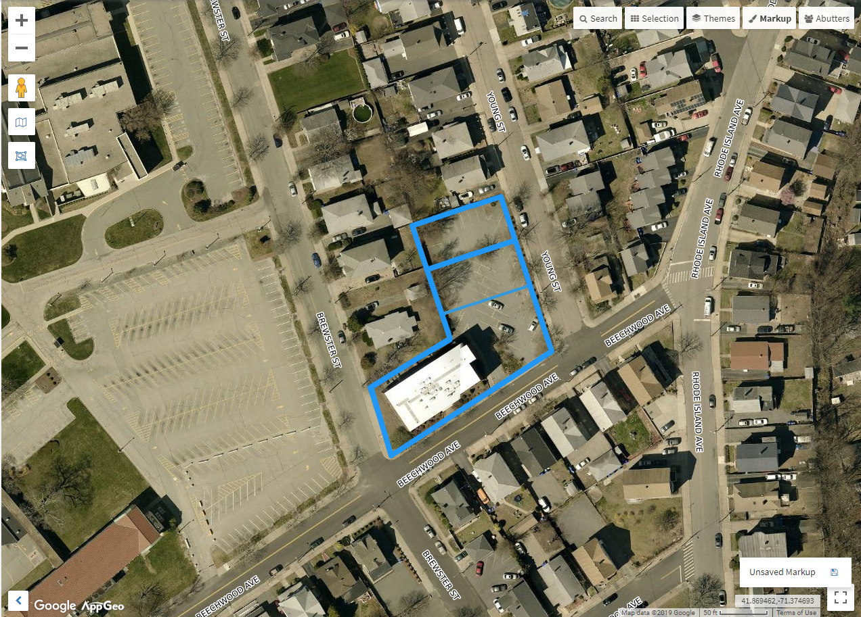

**160 BEECHWOOD PAWTUCKET, RI**